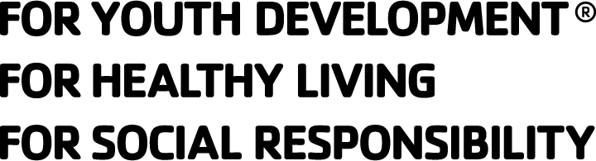
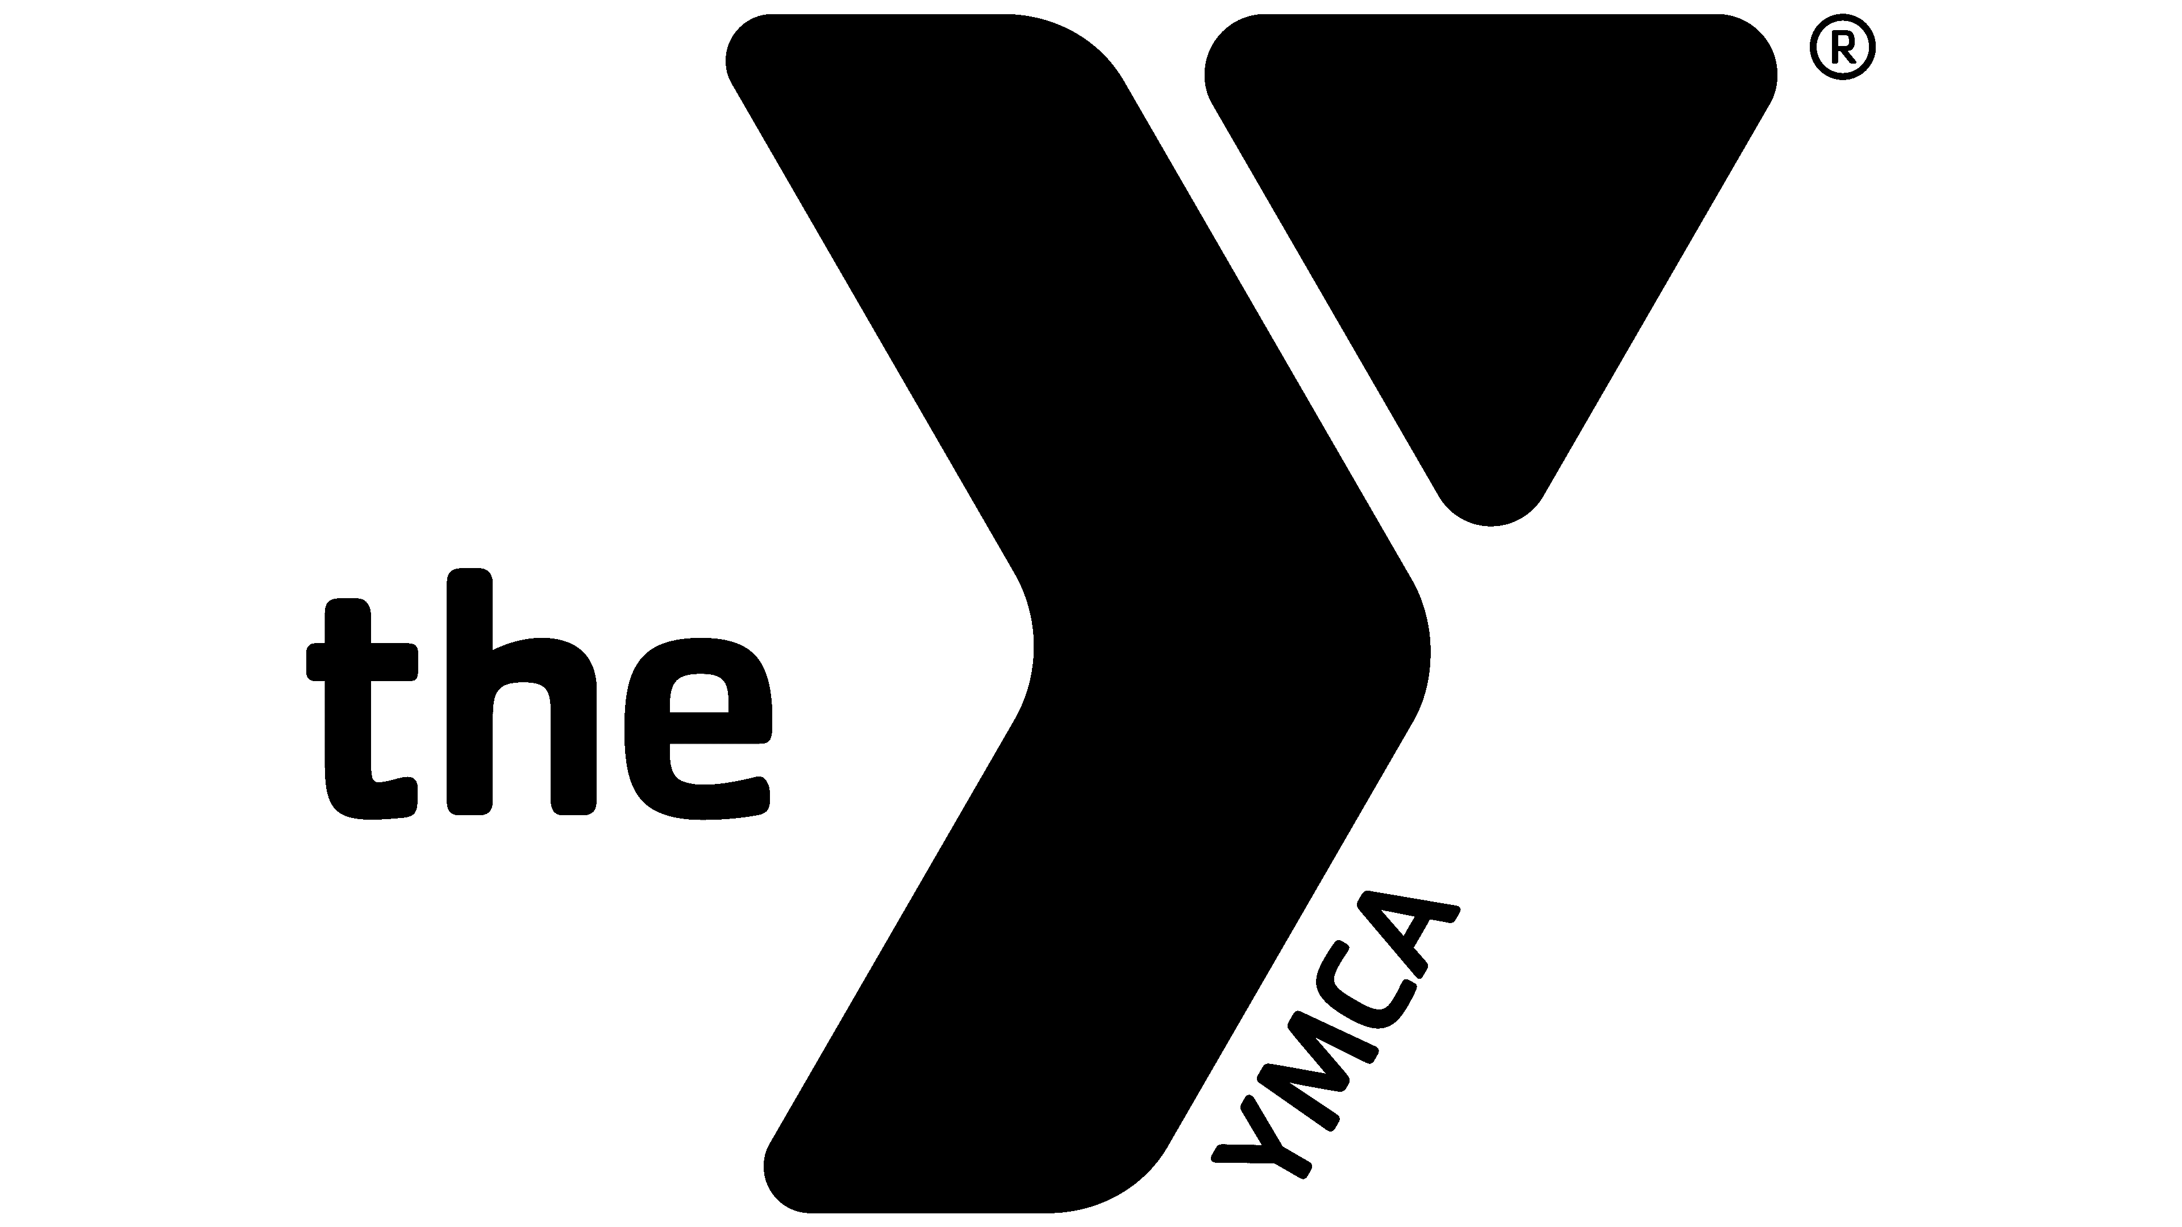
LEADERS CLUB
MEMBERSHIP APPLICATION

Basic Information
Name: ________________________________________ Age: __________
Address: _____________________________________________________
City: _______________________ State: ________ Zip Code: ___________
Home Phone: ( ) _________ - _____________
Cell Phone: ( ) _________ - _____________
E-mail Address: ________________________ Date of Birth: ____________
School Attending: ___________________________ Grade: _____________
Shirt Size: YL Small Medium Large XL XXL

Emergency Information
Parent / Guardian: ___________________________________________________
Phone: ( ) _________ - _____________
Cell Phone: ( ) _________ - _____________
Work Phone: ( ) _________ - _____________
Email: _______________________________________

Parent / Guardian: ___________________________________________________
Phone: ( ) _________ - _____________
Cell Phone: ( ) _________ - _____________
Work Phone: ( ) _________ - _____________
Email: ________________________________________

Health Insurance Carrier ___________________________________________________
Policy Number: ______________________________________
Allergies / Medications / Health Concerns:

Ground Rules & Behavior Guide
I the undersigned completely understand and accept my commitment to the Southside VA Family YMCA Leaders Club. I will do my very best to adhere to its guidelines as listed below as well as others when directed by the club advisor, YMCA volunteers and YMCA staff. I understand that as a leader in the Leaders Club program I am expected to behave in accordance with the YMCA character values of Caring, Honesty, Respect, Responsibility.

Accept and respect others
One mic (one person talks at a time)
Avoid put downs
Speak for yourself
You have the option to pass
You are responsible for your own learning
Expect and accept unfinished business
Maintain group confidentiality

Leaders Club Member Signature:
____________________________________________
Date: ____________________

Leaders Club Advisor Signature:
____________________________________________
Date: ____________________

About You
What is your favorite color(s)?

What is your go to song?

What hobbies do you have?

With the four core values being caring, honesty, respect, and responsibility, which is most important to you and why?

About the Future
What do you want to do after high school / college?

What are you looking forward in leaders club? What are you looking forward to getting out of Leaders Club?

What made you want to join YMCA Leaders Club?

Leaders’ Club is a high commitment and high standards club. We have weekly meetings with attendance requirements, yearly volunteer hours and healthy living component as well. Leader’s Club is also a family where you will grow and thrive. You will make positive friends who will inspire you to be a better person and leaders. Do you understand and accept these expectations?
____ Yes, I do _____No, I do not

Disclaimer
The Southside VA Family YMCA Leaders Club program involves a variety of activities including but not limited to active games, adventure and outdoor education, low and high ropes courses, community and volunteer service, creative arts and values exploration sessions that may be physically, mentally and emotionally demanding. Participation in the Leaders Club program is always voluntary.

Transportation Agreement
I understand that as part of the Leaders Club program transportation may be required for special events, trips, and retreats. In such instances where transportation is required, I hereby authorize my child to ride a YMCA bus or third-party transportation vehicle including third party vans, busses and public transportation. I understand that if my child acts in a way that is considered unsafe, as per the discretion of the staff or volunteers, they will be no longer allowed to attend trips and may be required to be picked up at the parent’s and/or guardian’s expense.

Permission for Medical Treatment
I hereby authorize the staff of the Southside VA Family YMCA to give First Aid and CPR to my child as needed. I understand that the staff are trained in the basics of First Aid and CPR. In the event of an emergency, I hereby authorize the program staff to have my child transported to the nearest medical facility and secure necessary medical treatment including, but not limited to: hospitalization, injections, anesthesia and/or surgery. In the event that I cannot be reached, I hereby give permission to the physician attending to my child to secure and administer treatment as necessary. I understand that the staff will make every effort to notify me of the emergency immediately.

Academic Assessment
I authorize the YMCA Program to check my child’s grades each nine weeks to assess my child’s academic GPA to make sure it matches that of the club GPA requirement

_____ Yes _____ No
Promotion
I hereby grant consent and authorize the use of photographs, slides, videotapes and file of myself and my minor child participating in YMCA activities for commercial and art purposes in any medium of advertising, communication, publication, or publicity that will promote YMCA programs and services, and/or recognition of participants.

Participant Signature: _________________________________ Date: __________

Parent Signature (if under 18): ____________________________________________

